**TITLE: Smart Travel Planning Website**



The Smart Travel Planning website is a platform designed to assist travelers in planning their trips effortlessly and efficiently. The website's primary purpose is to make trip planning more intuitive by offering highly personalized and season-specific recommendations, ensuring travelers make the most of their vacations. When users input their vacation dates, the platform intelligently checks if the selected destination is optimal for visiting during that particular time of year, considering weather conditions, thereby enhancing the overall travel experience.

In addition to seasonal suggestions, the website recommends based on the user’s travel companions, whether traveling as a couple, with family, friends, or solo. It provides users with personalized suggestions for must-visit places near their chosen destination, ensuring that their trip is customized to suit their preferences and the nature of their company.

Furthermore, the platform generates a detailed roadmap that highlights key attractions and famous landmarks near the chosen destination. This roadmap is optimized for efficient travel, allowing users to save time by organizing visits to nearby locations in a logical sequence. To enhance convenience, the platform also offers estimated costs for transportation, accommodations, and activities, giving users a clear understanding of the budget required for their entire trip.

With real-time updates, accurate cost predictions, and itinerary customization, the Smart Travel Planning website removes the complexities of travel planning. By handling the logistics and providing personalized recommendations, it allows travelers to focus on what truly matters—enjoying their journey and creating unforgettable memories.

Mr J. Sai Chandu Dr Rama Arunmozhi

**TITLE: Smart Travel Planning Website**



**THE FIELD OF INVENTION**

Our platform offers a seamless experience for travelers, simplifying the entire trip planning process. With a user-friendly interface, travelers can effortlessly explore and select destinations, plan their trips, and receive personalized recommendations based on their travel preferences. The platform provides real-time updates on the suitability of destinations for specific travel dates, ensuring users are guided toward the best locations for the season. It also tailors suggestions based on whether the traveler is going as a couple, with family, friends, or solo, while offering detailed itineraries and estimated costs to make the planning process efficient and stress-free.

**BACKGROUND OF THE INVENTION**

In the travel industry, planning a trip can often be overwhelming and time-consuming, with travelers struggling to find suitable destinations, activities, and accommodations. Traditional methods require extensive research and can leave travelers feeling frustrated by information overload and unclear options. The platform provides personalized recommendations based on the traveler’s vacation dates, companions, and destination, ensuring users can efficiently plan their trips with minimal effort. By offering season-specific suggestions, tailored itineraries, and cost estimates, the website helps travelers plan memorable and stress-free vacations.

**SUMMARY OF THE INVENTION**

Data related to travel destinations, seasonal suitability, and trip preferences are readily accessible through our travel planning platform. Users can easily find personalized recommendations, explore nearby attractions, and view estimated costs, all in one convenient place.

Mr J. Sai Chandu Dr Rama Arunmozhi

**TITLE: Smart Travel Planning Website**



**Specifications**

**User Registration and Authentication:**Users can create an account with basic information and securely log in to access personalized features. New users are redirected to the login page after registration.

**Destination Selection:**Users can choose their travel destination from various global locations, with search and filter options based on preferences like region and interests.

**Vacation Date Input:**Users input their vacation dates, and the system checks destination visitability based on weather and seasonal events, offering alternative suggestions if needed.

**Travel Companion Selection:**Users specify their travel companions (couple, family, friends, solo), allowing for tailored recommendations that meet their specific needs.

**Personalized Travel Recommendations:**The platform generates customized suggestions for places and activities based on selected destinations, dates, and travel companions.

**Roadmap Creation:**A detailed roadmap is provided, optimizing routes to nearby attractions, saving time, and enhancing the travel experience.

Mr J. Sai Chandu Dr Rama Arunmozhi

**TITLE: Smart Travel Planning Website**



The Smart Travel Planning website is a platform designed to simplify the trip planning process for travelers. It enables individuals to effortlessly plan their journeys by selecting destinations, inputting vacation dates, and specifying their travel companions. The website offers personalized recommendations for activities and attractions, generates optimized roadmaps, and provides cost estimations to help users manage their budgets. Additionally, the platform keeps users informed with real-time updates on weather conditions and travel restrictions, ensuring a smooth and enjoyable travel experience.

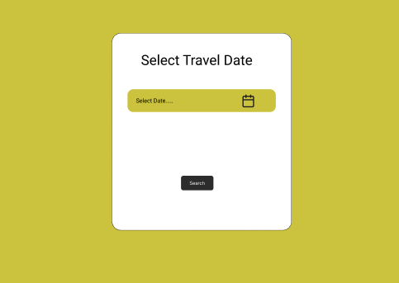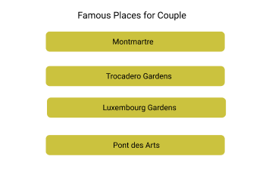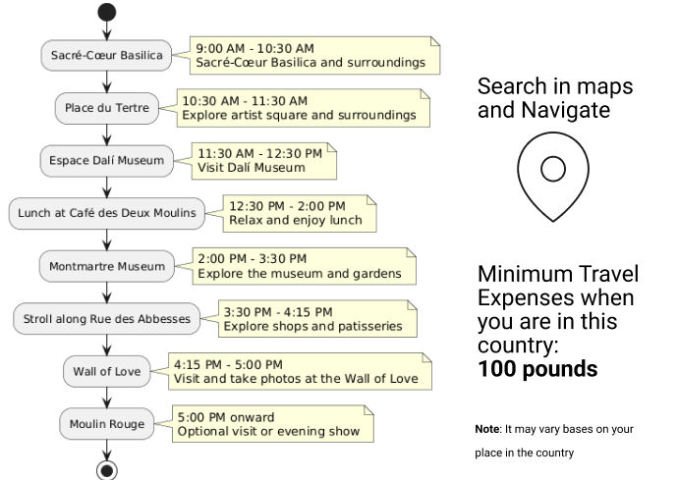

page 1: Select Date page 2: Travelling People page 3: Famous Places page 4: Roadmap Suggesting



Mr J. Sai Chandu Dr Rama Arunmozhi

**TITLE: Smart Travel Planning Website**



**We Claim**

**CLAIM:** Collaborative Trip Analysing

Our Smart Travel Planning platform allows multiple users to access and analyze travel options simultaneously, enhancing planning experiences.

**CLAIM:** Personalized Trip Planning:

Our user-friendly interface simplifies itinerary customization, allowing customers to explore and personalize their travel plans.

**CLAIM:** Seasonal Recommendations

Our platform provides tailored destination suggestions based on the season, ensuring users experience the best travel options for their chosen time of year

**CLAIM:** Optimized Roadmap Suggestions

The Smart Travel Planning website generates optimized roadmaps, guiding users through efficient routes to maximize their time visiting top attractions and landmarks.

Mr J. Sai Chandu Dr Rama Arunmozhi